Computer Graphics

**Project Title: City River View Scenario**

Group: 03

Date of Submission: 23.09.2020

|  |  |  |
| --- | --- | --- |
| Student Name | ID | Section |
| Alam, Muntasir | 17-34712-2 | E |
| Saha, Sudipto | 17-34582-2 | E |
| Mahamud, Nabi | 18-37013-1 | E |

**Introduction:** Computers have become a powerful tool for the rapid and economical production of pictures. There is virtually no area in which graphical displays cannot be used to some advantage, and so it is not surprising to find the use of computer graphics so widespread. Although early applications in engineering and science had to rely on expensive and cumbersome equipment, advances in computer technology have made interactive computer graphics a practical tool. Today, we find computer graphics used routinely in such diverse areas as science, engineering, medicine, business, industry, government, art, entertainment, advertising, education, and training.

**Problem Statement:** Here we have used computer graphics OpenGL implement our mini project, City River View Scenario animation. By using it, we can create interactive applications which render high-quality city river view scenario. We used different primitives in openGL like quads, circle, polygon, line to construct the city river view scenario. Those primitives are used to draw different objects and there are some functions which are also used for some animation which are also included in our projects. We have created a city river scene of different view. There many view at different time and there are included some animation. We have implemented sounds & different objects in the scenario and some objects are in animated form like bus, boat, cloud, plane and balloon which make the project more realistic.

**Objective:** Design and develop a city river view scenario using openGL

**System Implementation Method:** We have used different resources to develop the project. These are:

* Code Blocks
* Computer
* OpenGL primitives

**Project Features:** We have implemented auto animation process in our project by using timer functions which will show different views of city river view. There are different views of city river scenario. We set time which will automatically moves from one view to another view and also used different objects in different view. The scenario contains sounds & many views those are day view, day rain view, night view, night rain view. We used different objects in day and night view. Some are missing in different view objects and some are animated, some are fixed. We used some functions that are already in the OpenGL. Those functions were used to create the objects, to make some objects animated configuration.

**Different view:**  The different views of our city river view scenario at different time are given below:

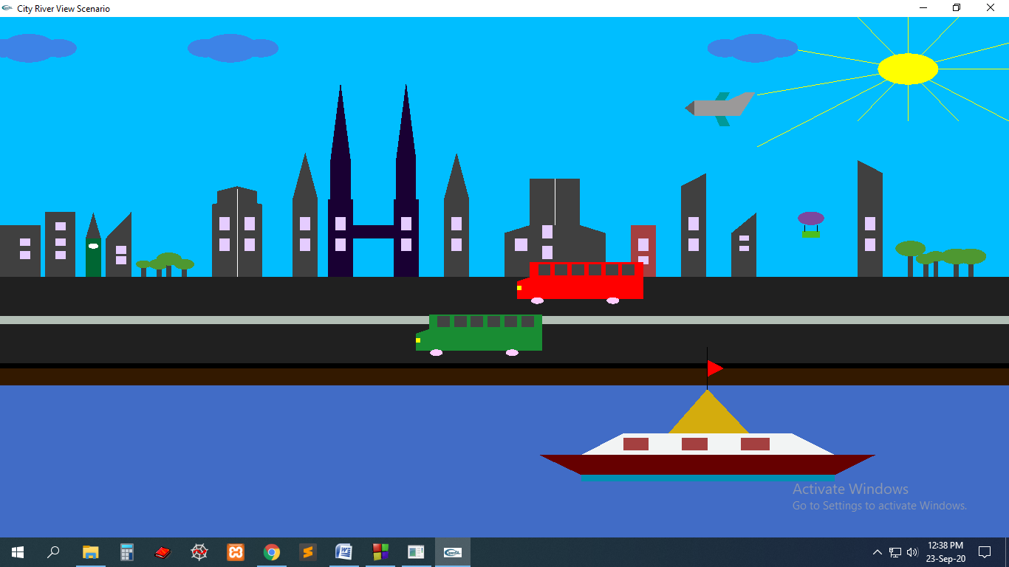**[ Day View ]**

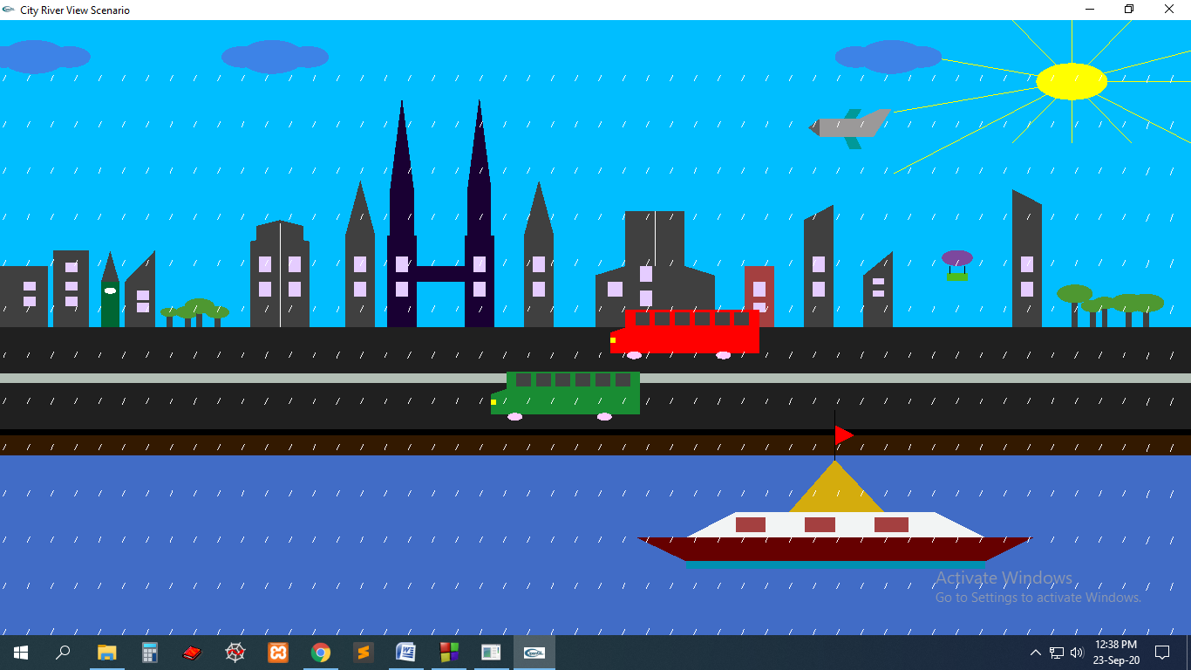 **[ Day Rain View ]**

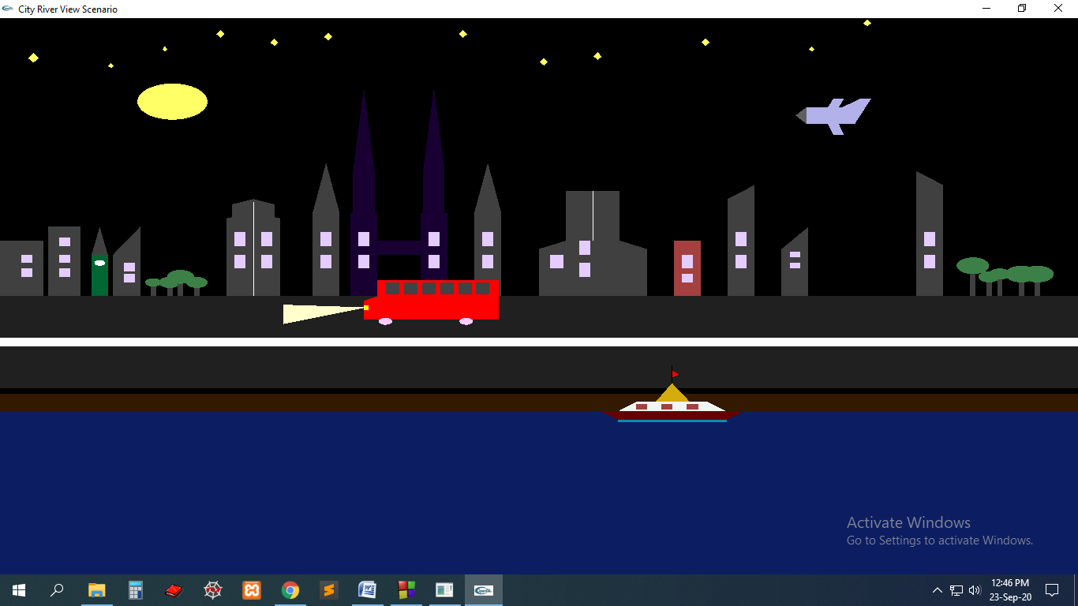

**[ Night View ]**

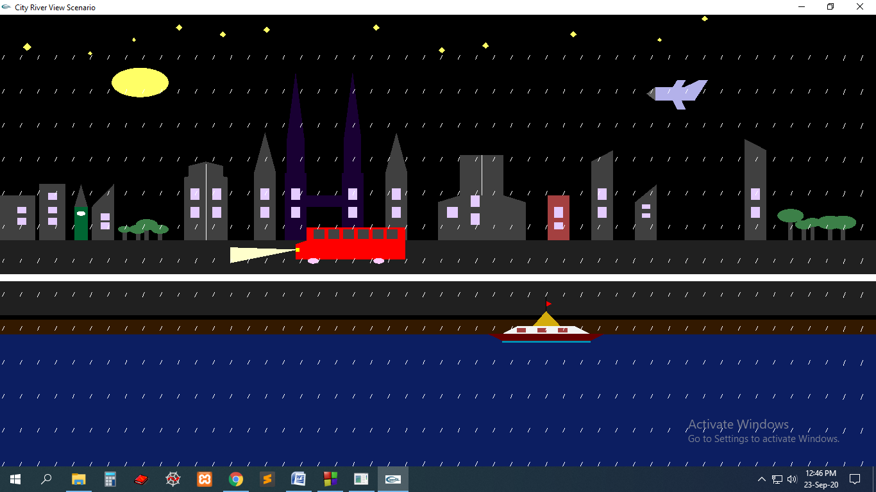

**[ Night Rain View ]**

**Conclusion:** This project would be helpful for making many animations and mini projects. This types of project has lots of demand in animation market. It also bring a new generation of 2d animations.